SIMATS ENGINEERING
Saveetha Institute of Medical and Technical Sciences
ASSESSMENT 3
Assessment Tool 3: Application Based Questions
Cloud Computing and Big Data Analytics (CSA15)
Student Name | O. ESHANTH REDDY
Register Number | 1924260199
Course Name | Cloud Computing and Big Data Analytics
Course Code | CSA15
Course Outcome Covered | CO2 - Analyze virtualization architectures to identify performance and security issues in cloud computing environments (BL3)
Assessment Tool | Assessment Tool 3: Application Based Questions
Assessment Weightage | 10%
Dave's Taxonomy Level | Manipulation (Level 2)
Question Count / Total Marks | 5 questions / 25 marks

Topics: Auto-Scaling and Load Balancing | Cloud Storage and Disaster Recovery | CDN and Global Availability | Compliance and Security | Containers and Kubernetes

Code of Conduct
I O. ESHANTH REDDY (Register No: 1924260199) certify that this submission is my original work and that I have adhered to the guidelines specified for this assessment.
I understand that any violation of academic integrity rules will result in disciplinary action.

Signature of the student: ____________________________
Name: O. ESHANTH REDDY
Register Number: 1924260199
Date: 26 October 2026

Contents of this Assessment
Question | Application Scenario
Question 1 | Auto-scaling and load balancing for seasonal e-commerce traffic spikes
Question 2 | Secure, durable and low-cost cloud backup storage and disaster recovery
Question 3 | Global deployment of a mobile app using CDNs and edge servers
Question 4 | Regulatory compliance, auditing and data sovereignty for a financial institution
Question 5 | Containerization, Kubernetes orchestration and microservices

Question 1: Auto-Scaling and Load Balancing for Seasonal Traffic
Scenario
A company experiences unpredictable traffic spikes during seasonal sales. Explain how cloud auto-scaling and load balancing can handle this demand efficiently. How does this approach reduce downtime and improve user experience? What role do monitoring tools play in this setup? Relate your answer to a real-world e-commerce scenario.

1.1 The Problem: Unpredictable Demand
An online retailer may serve a few hundred requests per second on a normal day, but a festive sale, a flash discount or a viral social-media post can multiply that load ten times or more within minutes. In a traditional data centre the company must buy servers for the worst-case peak. Those servers sit idle for most of the year (wasted money), and if the peak turns out higher than predicted, the site slows down or crashes exactly when customers are ready to buy (lost revenue and reputation).
Cloud computing solves this with elasticity: the ability to add or remove computing resources automatically, in step with demand, and to pay only for what is used. Two services work together to deliver this: load balancing, which spreads traffic across servers, and auto-scaling, which changes the number of servers.

1.2 How Load Balancing Works
A cloud load balancer (for example AWS Elastic Load Balancing, Azure Load Balancer or Google Cloud Load Balancing) is the single entry point for user traffic. It receives each request and forwards it to one of several healthy back-end servers using an algorithm such as round robin, least connections or weighted routing. Its main functions are:
- Traffic distribution: no single server is overloaded while others are idle.
- Health checks: the load balancer regularly probes every server; a server that fails is removed from rotation and requests go only to healthy ones.
- Multi-zone routing: servers placed in several Availability Zones keep the shop running even if one data-centre zone fails.
- SSL/TLS termination and session handling: encryption work is offloaded from application servers and user sessions can be kept consistent.

1.3 How Auto-Scaling Works
Auto-scaling (AWS Auto Scaling Groups, Azure Virtual Machine Scale Sets, Google Managed Instance Groups) keeps a group of identical servers created from a template image. The administrator defines a minimum size, a desired size and a maximum size, together with scaling policies. Three common policy types are used:
- Target tracking (dynamic): keep average CPU at about 60%; the service adds or removes servers to hold that target.
- Scheduled scaling: if the sale is known to start at 8 PM, capacity is increased at 7:45 PM so that servers are warm before customers arrive.
- Predictive scaling: machine-learning forecasts based on past traffic patterns provision capacity ahead of expected peaks.
When load rises, the group performs scale-out (adds servers). When load falls after the sale, it performs scale-in (terminates extra servers) so costs drop back to normal. The load balancer automatically registers new servers and de-registers terminated ones.
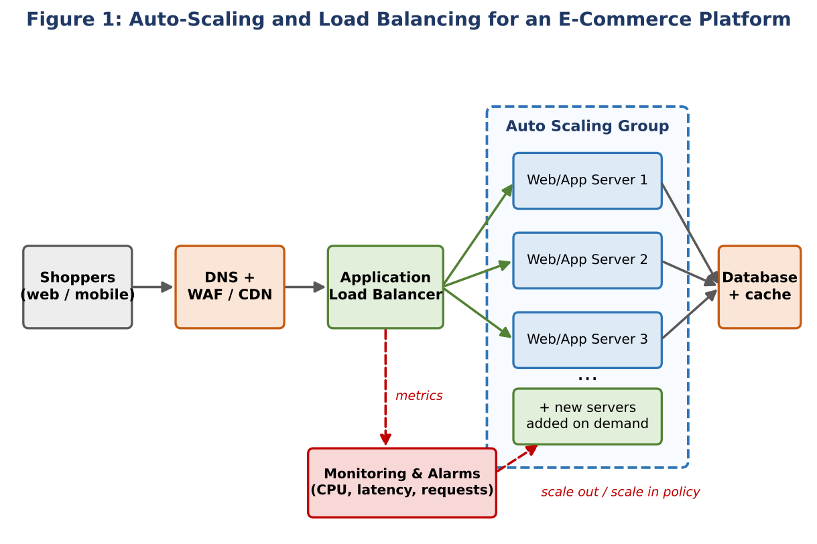

1.4 Real-World E-Commerce Scenario
Consider an online fashion retailer (called ShopKart here for illustration) that runs a 48-hour festive sale. Normally it needs 4 web servers. At 8 PM on the first day, a push notification sends millions of users to the site at the same time. The following sequence takes place:
- Traffic climbs from 1,200 to nearly 9,000 requests per second within a few minutes.
- Average CPU on the 4 servers crosses the 60% target; the monitoring service raises an alarm.
- The scaling policy launches additional servers from a pre-configured machine image; within a couple of minutes they pass health checks and the load balancer starts sending them traffic.
- Product images and static pages are served from a CDN and cache layer, reducing the load on the application servers and database.
- After midnight traffic falls; scale-in removes the extra servers, and the company pays only for the hours they actually ran.
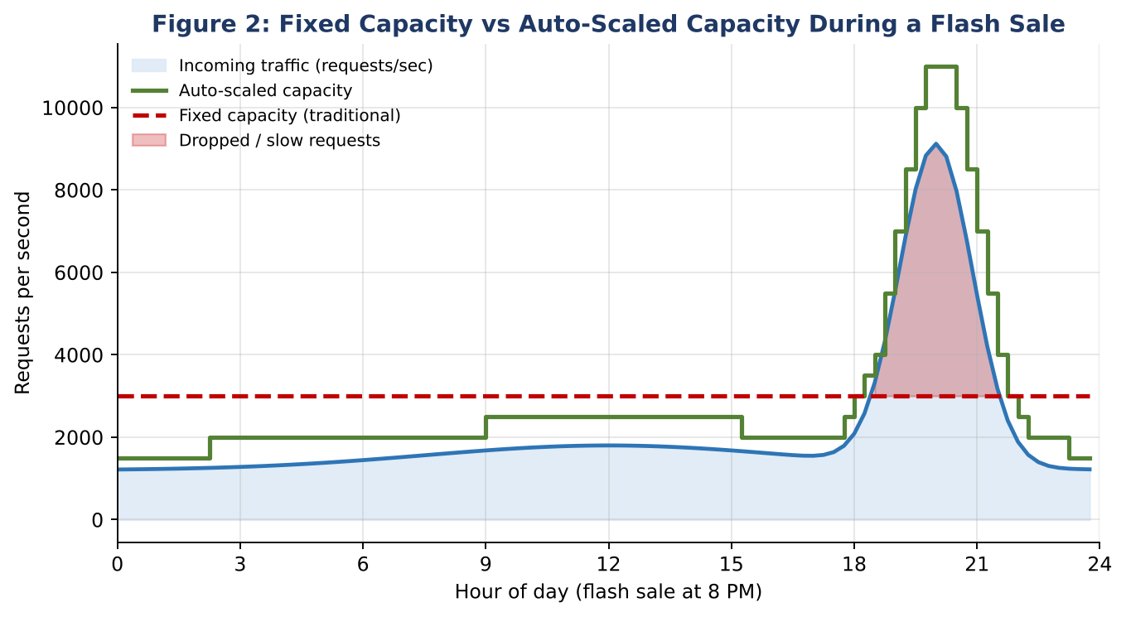
Figure 2 compares the two approaches. With fixed capacity (red dashed line), requests above the limit are dropped or served slowly. With auto-scaling (green line), capacity follows the traffic curve with a safety margin, so almost every customer is served. Large e-commerce platforms rely on exactly this elastic pattern to survive festive-season peaks.

1.5 Reducing Downtime and Improving User Experience
Aspect | Without auto-scaling / load balancing | With auto-scaling and load balancing
Server failure | Site or a part of it goes down until staff repair it | Unhealthy server removed from rotation; replacement launched automatically
Traffic spike | Slow pages, time-outs, HTTP 5xx errors | Capacity grows in minutes; response time stays stable
Zone / data-centre outage | Complete outage | Traffic continues from servers in other Availability Zones
Deployments | Maintenance windows and downtime | Rolling updates: servers replaced one at a time with no visible outage
Cost | Pay for peak capacity all year | Pay only for capacity actually used

For the customer, the benefits are fast page loads, a smooth checkout and no lost shopping carts. For the business, higher availability directly turns into higher conversion rates, better customer loyalty and fewer support complaints. Studies on web performance consistently show that even small delays in page load time reduce conversion, so keeping latency low during a sale is a revenue issue, not only a technical one.

1.6 Role of Monitoring Tools
Monitoring is the "nervous system" of an elastic architecture. Auto-scaling can only react to what it can measure. Tools such as Amazon CloudWatch, Azure Monitor and Google Cloud Operations (together with open-source options such as Prometheus and Grafana) collect and analyse:
- Infrastructure metrics: CPU utilisation, memory, network throughput, disk I/O and instance health.
- Application metrics: requests per second, response latency, error rates, queue length and database connections.
- Business metrics: orders per minute, payment failures and cart abandonment.
These metrics drive three activities: (1) triggering scaling policies through alarms and thresholds; (2) alerting engineers by e-mail, SMS or chat when error rates or latency go beyond limits; and (3) analysis through dashboards and logs, which helps in capacity planning, in finding bottlenecks (for example a slow database query) and in tuning the scaling policy after every sale. Distributed tracing and log aggregation further help to locate the exact service responsible for a slowdown.

1.7 Summary
Load balancing distributes requests and hides failures, auto-scaling matches capacity to demand, and monitoring provides the data that connects the two. Together they let an e-commerce company handle unpredictable seasonal spikes with minimal downtime, a consistent customer experience and a pay-per-use cost model.

Question 2: Secure and Durable Cloud Backup Storage
Scenario
An organization wants to store large volumes of backup data securely in the cloud. Discuss how cloud storage solutions ensure durability and data redundancy. How can encryption and access control protect sensitive backup data? Explain the cost advantages compared to traditional storage systems. Provide an example of a disaster recovery use case.

2.1 Why Cloud Storage for Backups
Backup data has a special profile: it is written often, read rarely, and must survive any disaster, including the loss of the primary site. Cloud object storage services such as Amazon S3 (with S3 Glacier tiers), Azure Blob Storage and Google Cloud Storage are designed for exactly this profile. They provide practically unlimited capacity, built-in redundancy, strong security features and pay-as-you-go pricing.

2.2 Durability and Data Redundancy
Durability is the probability that stored data is not lost over time, while availability is the probability that it can be accessed at a given moment. Cloud providers engineer extremely high durability (for example, Amazon S3 Standard is designed for 99.999999999%, i.e. "eleven nines", of object durability) through several techniques:
- Replication across Availability Zones: every object is stored redundantly on multiple devices in at least three physically separate zones of a region, so the failure of a disk, rack or even a whole data centre does not cause data loss.
- Erasure coding: data is split into fragments with additional parity fragments; the original can be rebuilt even when several fragments are lost, using less space than full copies.
- Cross-region replication: objects can be copied automatically to a second geographic region, protecting against regional disasters such as floods or earthquakes.
- Integrity checking: checksums are verified continuously, and corrupted copies are automatically repaired from healthy copies (self-healing).
- Versioning and object lock: earlier versions of a file are retained, and write-once-read-many (WORM) locks stop ransomware or accidental deletion from destroying backups.
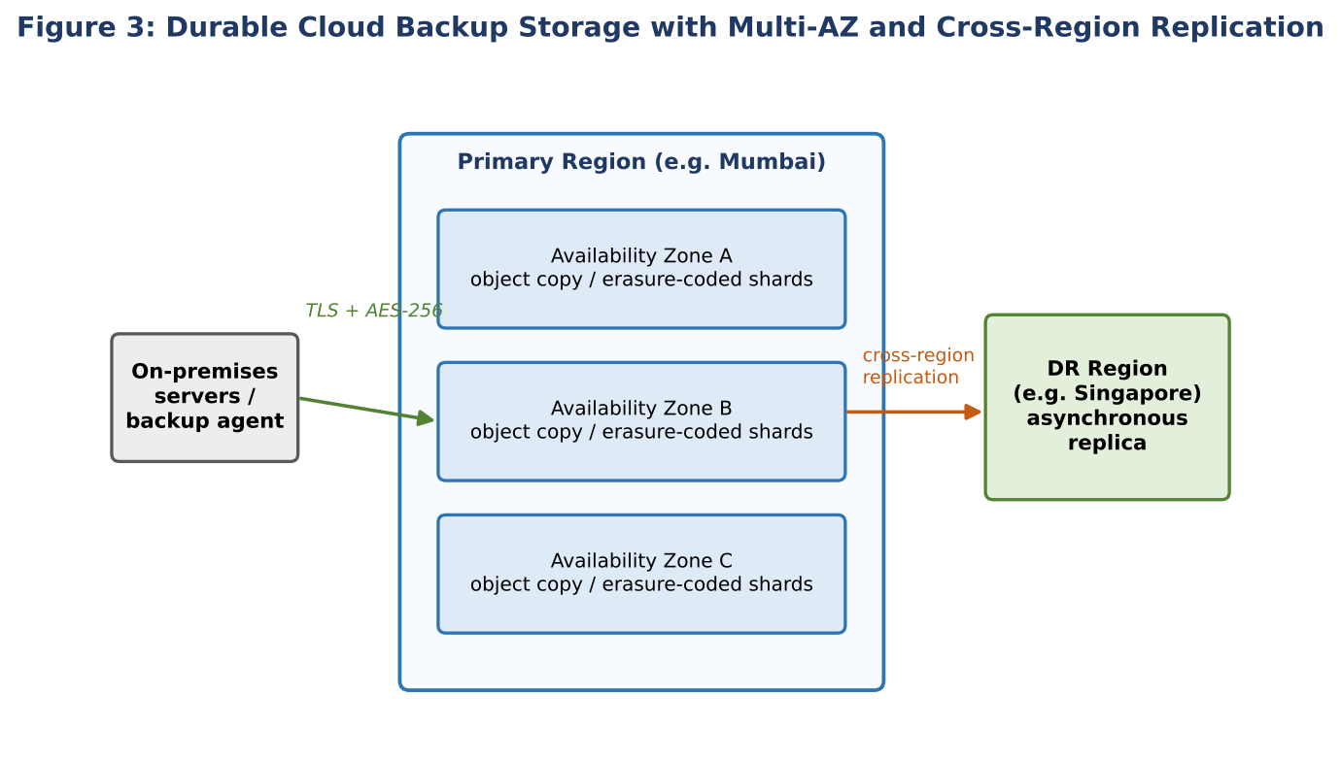

2.3 Protecting Sensitive Backups: Encryption
Backups often contain customer records, financial data and intellectual property, so they must be protected at every stage:
- Encryption in transit: data travels from the organization to the cloud over TLS (HTTPS) or through a private link or VPN, preventing interception.
- Encryption at rest: objects are encrypted with strong algorithms such as AES-256. Server-side encryption is automatic; client-side encryption lets the organization encrypt before upload so the provider never sees plaintext.
- Key management: keys are stored and rotated in a managed Key Management Service (KMS) or a hardware security module (HSM). Customer-managed keys let the organization revoke access by disabling a key.

2.4 Protecting Sensitive Backups: Access Control
- Identity and Access Management (IAM): the principle of least privilege - the backup application can write but not delete; only a small group of administrators can restore.
- Multi-factor authentication (MFA) and MFA-delete: extra verification before destructive operations.
- Bucket policies and network controls: block all public access, restrict access to specific IP ranges or private endpoints.
- Logging and alerts: every access request is recorded (for example in CloudTrail or Azure Activity Log) so unusual activity can be detected and investigated.
- Separation of duties and immutable copies: backup administrators are separated from production administrators so that a compromised production account cannot erase the backups.

2.5 Cost Advantages over Traditional Storage
Traditional backup relies on tape libraries or on-premises disk arrays that require up-front capital expenditure, data-centre space, power, cooling, maintenance contracts and staff, and they must be sized for future growth. Cloud storage converts this into operational expenditure with several advantages:
Factor | Traditional on-premises | Cloud storage
Up-front investment | High (hardware, licences, racks) | None; pay as you go
Capacity planning | Over-provision for growth | Elastic; grows with data
Redundancy | Buy second site and duplicate hardware | Built in at no extra effort
Operations | Replace disks, manage tapes, patch systems | Managed by the provider
Data ageing | Same expensive storage for all data | Lifecycle rules move old backups to cheap archive tiers
Power, cooling, space | Paid by the organization | Included in the service price

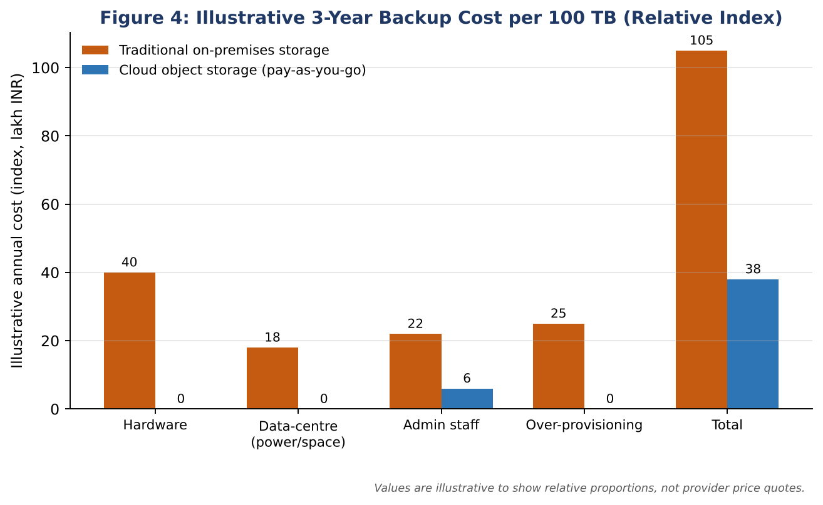
Storage tiering adds further savings: recent backups stay in a standard tier for quick restore, backups older than 30 days automatically move to an infrequent-access tier, and those older than 90 days move to archive storage (for example Glacier Deep Archive), whose price per gigabyte is a small fraction of standard storage. Organizations should still account for retrieval fees, request charges and data egress costs when planning restores.

2.6 Disaster Recovery Use Case
Consider a hospital group that runs its patient-records system in a primary data centre. Nightly and hourly backups are encrypted and sent to cloud storage, and replicated to a second region. One monsoon season the primary data centre is flooded and all servers are lost.
- Monitoring detects that the primary site is unreachable, and the disaster-recovery plan is activated.
- The IT team launches virtual machines and databases in the DR region from pre-built templates.
- The latest encrypted backup is restored from the replicated storage; the encryption keys are available through the key-management service.
- DNS is switched to the DR environment, and staff resume work.
- When the primary site is rebuilt, data is synchronised back (fail-back).
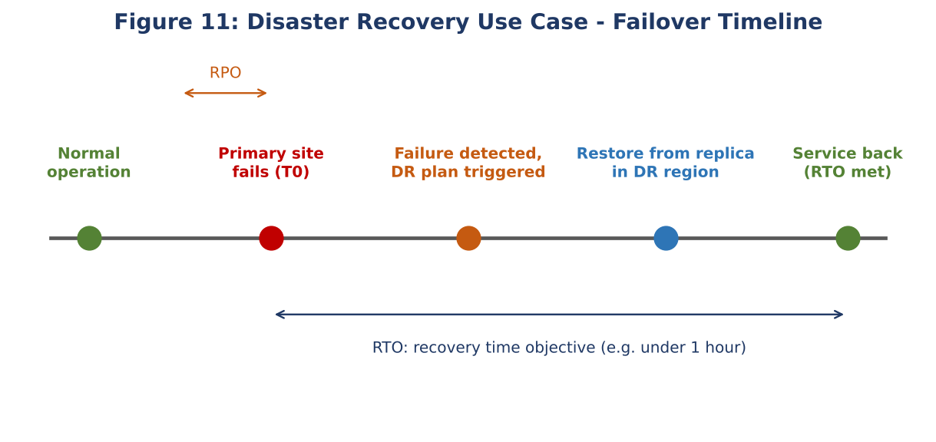
Two metrics define the quality of such a plan: the Recovery Point Objective (RPO), the maximum acceptable data loss measured in time (determined by backup frequency), and the Recovery Time Objective (RTO), the maximum acceptable downtime. Cloud makes low RPO and RTO affordable because the DR site is not a permanently running duplicate data centre: resources are created only when needed (the "pilot light" or "warm standby" model). Regular DR drills and restore tests are essential to confirm that backups are actually usable.

2.7 Summary
Cloud storage provides high durability through replication, erasure coding and cross-region copies; protects sensitive backups with encryption, key management and strict access control; reduces cost through pay-as-you-go pricing and tiering; and enables fast, affordable disaster recovery.

Question 3: Global Deployment Using CDNs and Edge Servers
Scenario
A mobile app company plans to deploy its application globally. Explain how content delivery networks (CDNs) improve performance and reduce latency. How do edge servers enhance user experience across regions? Discuss how cloud providers support global availability. Relate this to a real-time streaming or gaming application.

3.1 The Challenge of Distance
Network latency depends largely on the physical distance data must travel and the number of network hops. A user in Chennai connecting to a server in Virginia (USA) can experience a round-trip time of 250 milliseconds or more, even on a fast connection, because signals travel through undersea cables and many routers. For a mobile app that loads images, video and game assets, this delay accumulates and results in slow screens, buffering and frustrated users. Serving every user from one central location also overloads the origin server and its network link.

3.2 How a CDN Improves Performance
A Content Delivery Network is a geographically distributed network of cache servers, called edge servers or Points of Presence (PoPs). Providers include Amazon CloudFront, Azure Front Door and CDN, Google Cloud CDN, Cloudflare and Akamai. The process works as follows:
- The user's device requests a file (for example a video segment or a game texture). DNS or anycast routing directs the request to the nearest edge location.
- If the edge server already holds a fresh copy (a cache hit), it returns the file immediately.
- If not (a cache miss), the edge fetches the file from the origin, stores a copy according to caching rules (TTL), and returns it. Later users in the same region receive the cached copy.
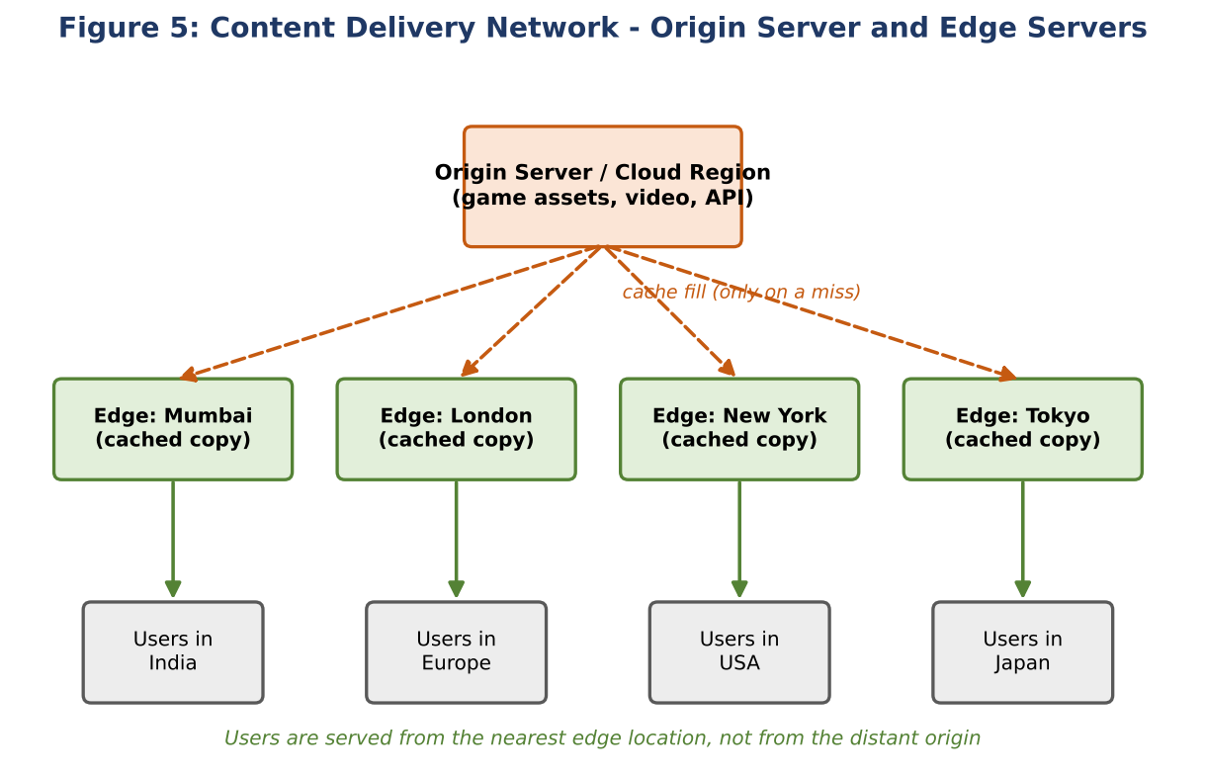
CDNs improve performance through several mechanisms:
- Reduced latency: content travels a short distance from a nearby edge instead of crossing continents.
- Reduced origin load and bandwidth cost: most requests never reach the origin, so fewer servers are needed.
- Optimised connections: persistent connections, TCP/TLS optimisation, HTTP/2 and HTTP/3 (QUIC), and compression such as Brotli and gzip speed up transfers.
- Traffic absorption and security: the distributed network absorbs sudden surges and DDoS attacks, and many CDNs add a Web Application Firewall and bot protection.
- Image and video optimisation: automatic resizing and adaptive formats suit different mobile devices and network speeds.
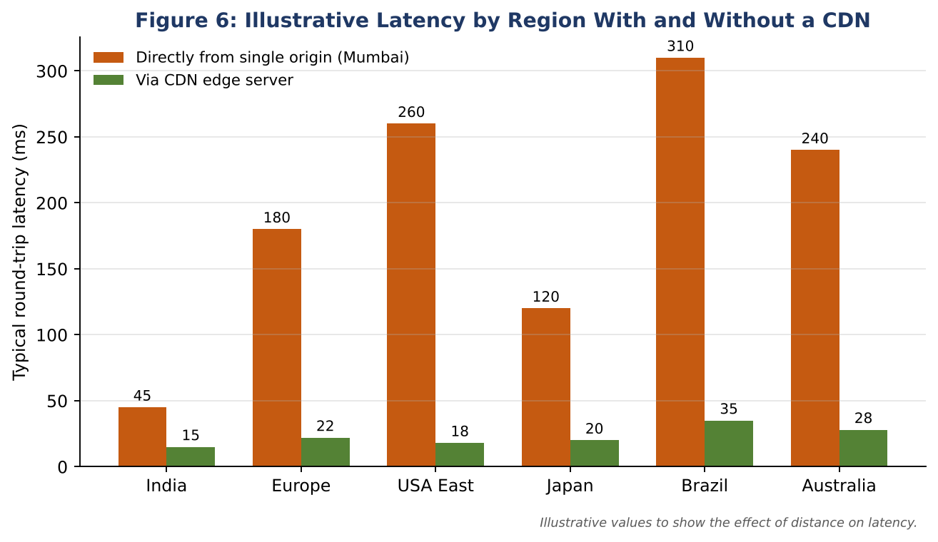

3.3 How Edge Servers Enhance User Experience Across Regions
Edge servers bring the application closer to the user. For a global mobile app this means:
- Consistent experience: users in India, Europe and North America experience similar load times instead of only users near the origin getting good performance.
- Better performance on weak mobile networks: fewer hops and shorter distances reduce packet loss and retransmissions, which matter greatly on 4G/5G links with variable quality.
- Edge computing: modern platforms (Lambda@Edge, CloudFront Functions, Cloudflare Workers) run small pieces of code at the edge for authentication checks, A/B testing, personalisation, URL rewrites and API response caching, avoiding a trip to the origin.
- Localised content: the edge can serve region-specific languages, prices and legal notices based on the user's location.
- Resilience: if one edge location or path fails, traffic is rerouted to another nearby location.

3.4 How Cloud Providers Support Global Availability
Beyond CDNs, major cloud providers offer a worldwide infrastructure on which the back-end of the app can also be deployed close to users:
- Regions and Availability Zones: independent geographic regions (such as Mumbai, Singapore, Frankfurt and N. Virginia), each with several isolated zones, enable multi-region deployment and failover.
- Global DNS and traffic management: services like Amazon Route 53, Azure Traffic Manager and Cloud DNS route users to the nearest or healthiest region using latency-based, geolocation or failover routing.
- Global load balancing and private backbone: traffic enters the provider's private high-speed network at the nearest edge location, which is usually faster and more reliable than the public internet.
- Multi-region data services: globally replicated databases and object storage (for example DynamoDB global tables, Cosmos DB, Cloud Spanner) keep data close to users and available during regional outages.
- Health checks and automatic failover: unhealthy regions are removed from DNS responses automatically.

3.5 Application Example: Live Streaming and Online Gaming
Video streaming. A streaming service divides each video into small segments in several bitrates (adaptive bitrate streaming such as HLS or MPEG-DASH). Popular titles are cached on edge servers near viewers; the player picks the best quality for the current bandwidth. Large streaming companies even place their own cache appliances inside Internet Service Provider networks, so that most viewing traffic never leaves the viewer's local network. Result: fast start-up time, minimal buffering and the ability to serve millions of concurrent viewers during a major event.
Online mobile gaming. Game assets such as maps, skins and patches are large and static, so they are ideal for CDN caching; downloads and updates finish quickly worldwide. For real-time gameplay, which cannot be cached, the game servers are deployed in several regions and players are matched to the nearest region to keep ping low (for example under 50 ms). Global accelerators carry the traffic over the provider's private backbone, reducing jitter and packet loss. If a region becomes overloaded, auto-scaling adds game servers; if it fails, players are redirected to another region.
Content type | Delivery method | Benefit
Static assets (images, game patches, app updates) | Cached at CDN edge | Fast download, low origin load
Video-on-demand and live segments | Edge caching with adaptive bitrate | Smooth playback, little buffering
Real-time game traffic / API calls | Regional servers + private backbone routing | Low latency and jitter
User data and profiles | Multi-region replicated database | Availability during regional failure

3.6 Summary
CDNs and edge servers cut latency by serving content from the nearest location, reduce load on the origin, and give users in every region a similar experience. Combined with multi-region deployment, global DNS routing and replicated data stores offered by cloud providers, a mobile app can achieve high performance and high availability on a worldwide scale.

Question 4: Compliance and Security for a Financial Institution
Scenario
A financial institution requires strict compliance and data security in cloud usage. Explain how cloud providers support regulatory compliance and auditing. What role do logging, monitoring, and encryption play in security? How can the company ensure data sovereignty requirements are met? Give an example involving sensitive financial transactions.

4.1 Compliance Needs of Financial Institutions
Banks, insurers and payment companies handle money and personal data, so they are among the most heavily regulated organizations. Depending on the country and business, they must follow standards and laws such as PCI DSS (payment card data), ISO/IEC 27001 and 27017/27018 (information security and cloud privacy), SOC 1/SOC 2 audits, the EU General Data Protection Regulation (GDPR), India's Digital Personal Data Protection Act 2023, and central-bank rules such as the Reserve Bank of India's directions on storage of payment system data in India and on outsourcing of IT services. Non-compliance can lead to heavy penalties, loss of licence and loss of customer trust.

4.2 The Shared Responsibility Model
Security in the cloud is shared. The provider is responsible for security *of* the cloud: physical data centres, hardware, the virtualization layer and core network. The customer is responsible for security *in* the cloud: identity management, data classification and encryption, application security, network configuration and operating-system patching (for IaaS). A bank must clearly understand this boundary, because most cloud breaches result from customer misconfiguration (for example publicly exposed storage) rather than provider failure.

4.3 How Cloud Providers Support Compliance and Auditing
- Certified infrastructure: providers undergo independent audits and publish certifications and reports (ISO 27001, SOC 1/2/3, PCI DSS Level 1, and others). Customers can download these through portals such as AWS Artifact or the Microsoft Service Trust Portal and reuse them as evidence for their own auditors.
- Compliance tooling: services such as AWS Config, Azure Policy and Google Security Command Center continuously compare resource settings with a rule set (for example "all storage must be encrypted") and flag or automatically fix violations.
- Audit trails: every API call and administrative action is logged with who, what, when and from where (AWS CloudTrail, Azure Activity Log, Cloud Audit Logs).
- Compliance-ready architectures: reference designs, landing zones and blueprints help banks build accounts and networks aligned to regulations from the start.
- Contractual commitments: data-processing agreements, breach notification terms and the right to audit support regulatory outsourcing requirements.
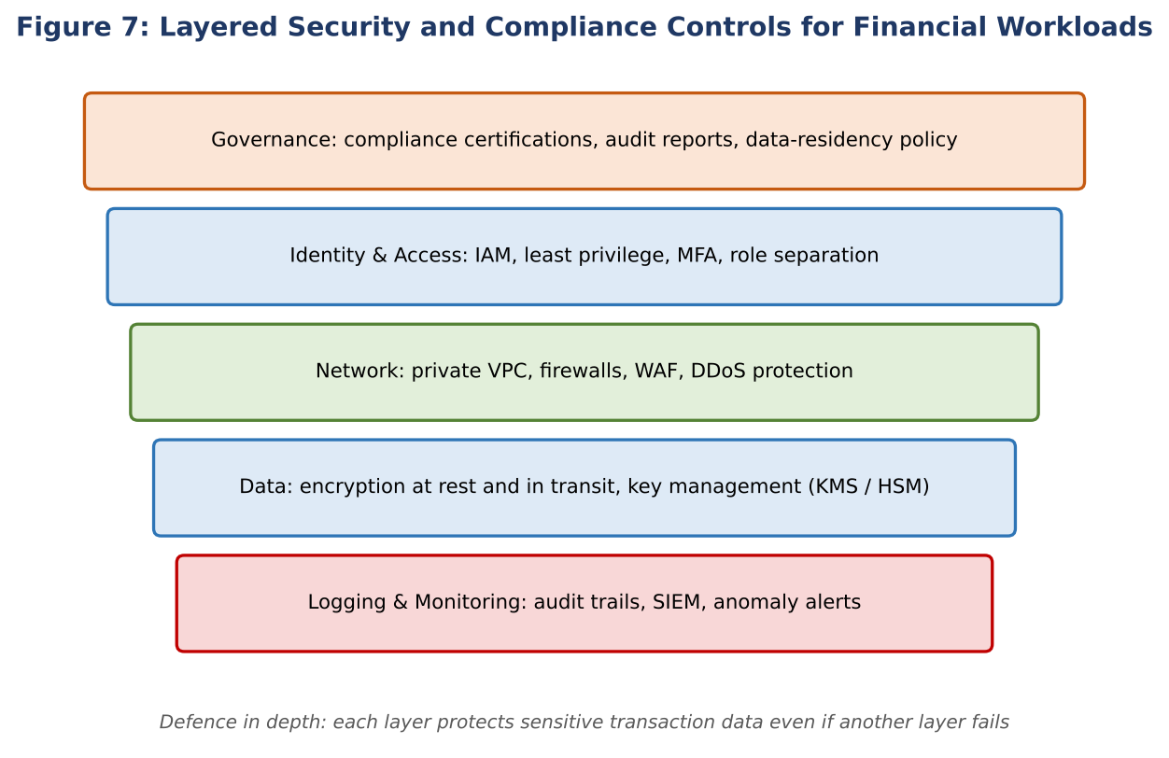

4.4 Role of Logging, Monitoring and Encryption
Logging provides a tamper-resistant record of what happened. Logs of authentication events, configuration changes, data access and network flows are sent to a central, write-protected store with long retention (often several years for financial records). They are the primary evidence during audits and forensic investigations.
Monitoring turns logs and metrics into real-time detection. A Security Information and Event Management (SIEM) system correlates events and raises alerts, for example for logins from unusual countries, a sudden large data download, privilege escalation, or an unusual burst of failed payments. Threat-detection services and anomaly detection using machine learning shorten the time to detect and respond. Automated responses can isolate a compromised instance or revoke a credential within seconds.
Encryption protects confidentiality even if other controls fail. Data is encrypted in transit (TLS 1.2 or higher, mutual TLS between services), at rest (AES-256 for databases, disks and backups) and, for highly sensitive fields like card numbers, tokenised or field-level encrypted. Keys are generated and kept in a KMS or hardware security module, rotated regularly, and under the bank's control (bring-your-own-key or customer-managed keys). Separation between key administrators and data administrators prevents any single person from reading the data.
Control | What it provides | Example in a bank
Logging | Evidence and traceability | Immutable log of every transfer approval and admin action
Monitoring / SIEM | Real-time detection and alerting | Alert when one account initiates many high-value transfers
Encryption | Confidentiality of data | Card numbers tokenised; database encrypted with customer-managed key
IAM + MFA | Only authorised people and services | Role-based access for tellers vs auditors; MFA for admins
Network isolation | Reduced attack surface | Private subnets, no public database endpoints, WAF in front of APIs

4.5 Ensuring Data Sovereignty
Data sovereignty means that data is subject to the laws of the country where it is stored or collected, and that regulators may require it to remain within national borders. To meet these requirements a financial institution can:
- Choose approved regions: deploy only in cloud regions located inside the required country or legal zone (for example Mumbai or Hyderabad for India), and store primary and backup copies there.
- Enforce region restrictions by policy: use organization-level guardrails (such as service control policies or Azure Policy) that deny creation of resources in any other region.
- Control keys locally: keep encryption keys in an in-country KMS or HSM under the bank's sole control, so foreign access to the data is cryptographically blocked.
- Control replication and support access: restrict cross-region replication to approved regions, and review provider support and sub-processor access arrangements in the contract.
- Use sovereign, dedicated or private options where needed: dedicated hosts, private cloud or sovereign-cloud offerings for the most sensitive systems.
- Verify continuously: use data-residency reports, audits and policy-compliance dashboards to prove to regulators where the data resides.

4.6 Example: Securing a Sensitive Payment Transaction
A customer in India transfers money using a mobile banking app. The flow below shows how the controls work together:
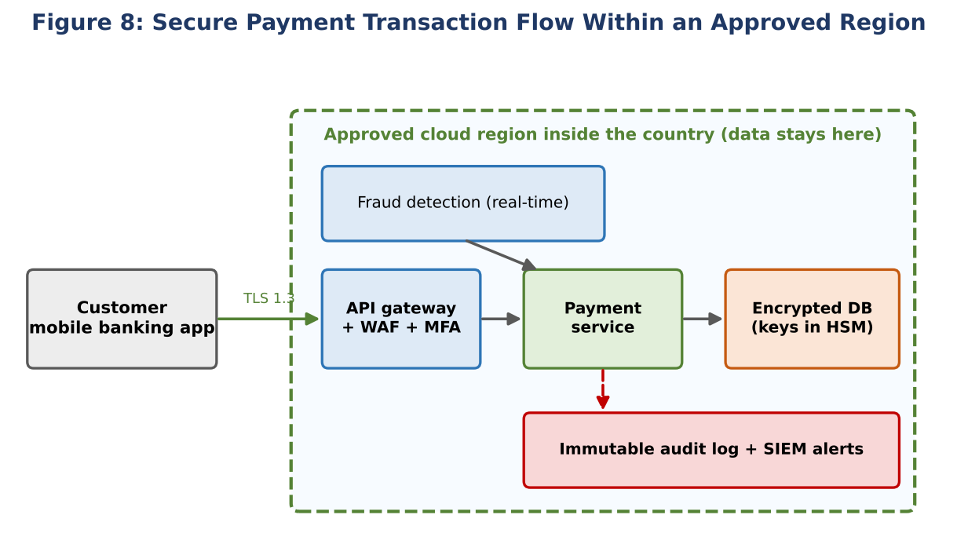
- The app connects over TLS 1.3 to an API gateway protected by a WAF; the customer passes multi-factor authentication (password plus one-time code or biometric).
- The request reaches the payment service in a private network inside the approved in-country region.
- A real-time fraud-detection service scores the transaction; suspicious ones are blocked or need extra verification.
- Account numbers and card data are tokenised, and the transaction is written to a database encrypted with keys stored in an HSM.
- Each step is written to an immutable audit log and streamed to the SIEM. Any anomaly triggers an alert to the security operations team.
- During the annual audit, the bank presents the provider's certifications, its own policy-compliance reports and the audit logs as evidence of compliance and of data residency.

4.7 Summary
Cloud providers supply certified infrastructure, compliance tooling and audit trails, while the institution remains responsible for configuring identity, encryption, monitoring and data location correctly. Logging, monitoring and encryption form the technical backbone of security, and region restrictions with locally controlled keys satisfy data-sovereignty rules, allowing a bank to use the cloud safely.

Question 5: Containerization, Kubernetes and Microservices
Scenario
A development team wants to adopt containerization for application deployment. Explain how containers differ from virtual machines in terms of performance and resource usage. How does orchestration (like Kubernetes) simplify deployment and scaling? Discuss portability benefits across different cloud environments. Provide an example of a microservices-based application.

5.1 Virtual Machines and Containers
A virtual machine (VM) emulates a complete computer. A hypervisor (such as KVM, VMware ESXi or Hyper-V) divides physical hardware into several VMs, and each VM runs its own full guest operating system along with the application and its libraries. This gives strong isolation, which is why VMs are the foundation of cloud IaaS, but each VM carries the weight of an entire OS.
A container packages only the application and its dependencies (libraries, runtime, configuration). All containers on a host share the host operating-system kernel and are isolated using Linux kernel features: namespaces (isolating processes, network and file systems) and cgroups (limiting CPU and memory). Docker, containerd and Podman are common container engines.
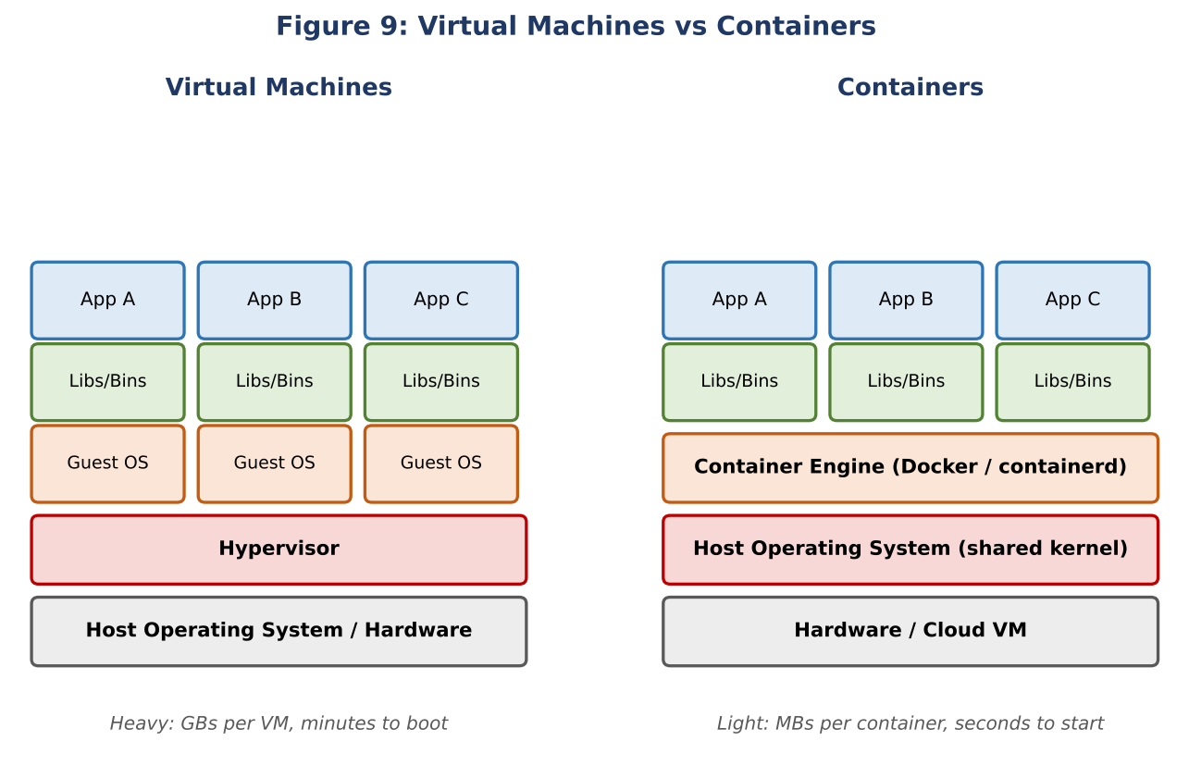

5.2 Comparison: Performance and Resource Usage
Aspect | Virtual Machines | Containers
Size | Gigabytes (includes full guest OS) | Megabytes (application + libraries only)
Start-up time | Tens of seconds to minutes | Milliseconds to a few seconds
Resource overhead | High: each VM needs its own OS memory, CPU and disk | Low: kernel is shared, so more workloads fit on one host
Density | Few VMs per server | Many containers (tens to hundreds) per server
Performance | Slight overhead from hypervisor and guest OS | Near-native performance
Isolation | Strong, hardware-level (separate kernels) | Process-level (shared kernel); weaker unless hardened or sandboxed
OS flexibility | Can run different operating systems side by side | Must be compatible with the host kernel (Linux containers on Linux)
Typical use | Legacy applications, strong multi-tenant isolation, different OSes | Microservices, CI/CD, scalable cloud-native applications

In practice, containers are very often run inside VMs in the cloud: the VM gives secure tenant isolation and the containers give efficiency and speed. Because containers are small and quick to start, scaling out a service means starting additional containers in seconds, and resources are used much more efficiently, which lowers cost.
Security point: since containers share a kernel, organizations should use minimal base images, scan images for vulnerabilities, run containers as non-root users, apply network policies and consider sandboxed runtimes for untrusted workloads. These performance, isolation and security trade-offs are central to analysing virtualization architectures (CO2).

5.3 How Kubernetes Simplifies Deployment and Scaling
Running a handful of containers by hand is simple; running hundreds across many servers is not. Container orchestration automates this work. Kubernetes (K8s), the most widely used orchestrator, has a *control plane* (API server, scheduler, controller manager and the etcd data store) and a set of *worker nodes* that run pods (the smallest deployable units, holding one or more containers). The administrator declares the desired state in YAML files, and Kubernetes continuously works to make the real state match it.
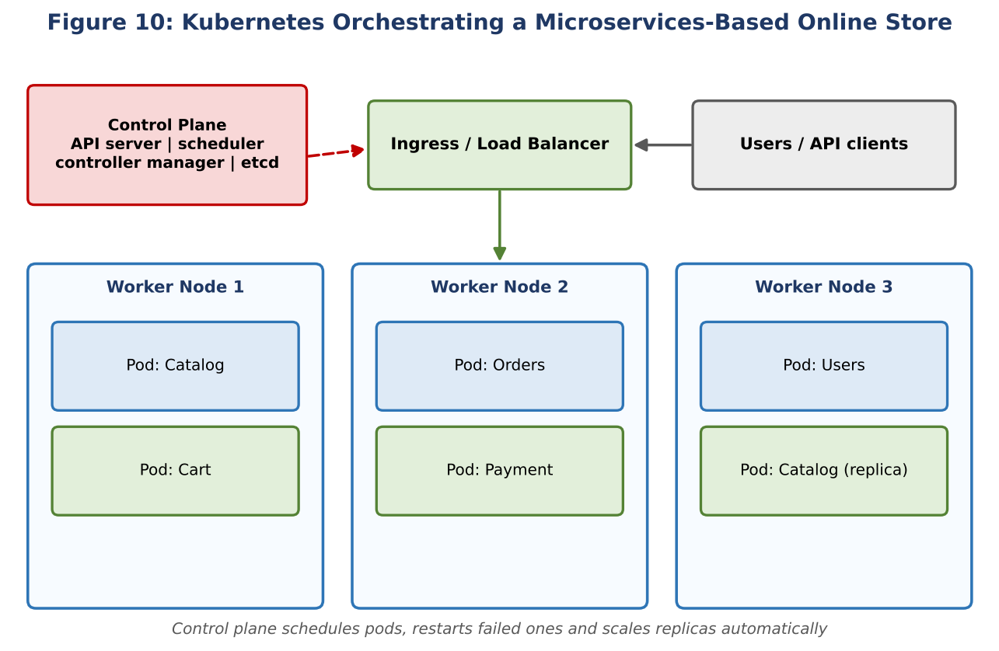
- Automated scheduling: the scheduler places pods on nodes with enough free CPU and memory.
- Self-healing: crashed containers are restarted; if a node dies, its pods are rescheduled on other nodes; failing health probes cause pods to be replaced.
- Horizontal scaling: the Horizontal Pod Autoscaler changes the number of replicas based on CPU or custom metrics, and the cluster autoscaler adds nodes when needed.
- Rolling updates and rollbacks: new versions replace old pods gradually with zero downtime; if the new version misbehaves, one command rolls back.
- Service discovery and load balancing: a Service gives a stable name and IP to a changing set of pods and balances traffic among them; Ingress controllers handle external HTTP(S) traffic.
- Configuration and secrets management: ConfigMaps and Secrets separate configuration from container images.
- Storage orchestration and resource control: persistent volumes, requests/limits and namespaces enable multi-team sharing of a cluster.
A small example of the declarative approach is shown below: it asks Kubernetes to keep three replicas of a shopping-cart service and to scale between 3 and 20 replicas to hold average CPU near 60%.
apiVersion: apps/v1
kind: Deployment
metadata:
name: cart-service
spec:
replicas: 3 # desired number of identical pods
selector:
matchLabels: { app: cart }
template:
metadata:
labels: { app: cart }
spec:
containers:
- name: cart
image: registry.example.com/shop/cart:1.4.2
ports: [{ containerPort: 8080 }]
resources:
requests: { cpu: 250m, memory: 256Mi }
limits: { cpu: 500m, memory: 512Mi }
---
apiVersion: autoscaling/v2
kind: HorizontalPodAutoscaler
metadata:
name: cart-hpa
spec:
scaleTargetRef: { apiVersion: apps/v1, kind: Deployment, name: cart-service }
minReplicas: 3
maxReplicas: 20
metrics:
- type: Resource
resource: { name: cpu, target: { type: Utilization, averageUtilization: 60 } }

5.4 Portability Across Cloud Environments
A container image bundles the application with everything it needs, so "it works on my machine" becomes "it works everywhere the container engine runs". The Open Container Initiative (OCI) standards for images and runtimes ensure compatibility between tools. Kubernetes provides a common API on every major platform: Amazon EKS, Azure AKS, Google GKE, on-premises clusters, and edge environments. The benefits are:
- Consistency across environments: the same image moves from a developer laptop to testing, staging and production without changes.
- Avoiding vendor lock-in: the team can migrate or spread workloads between cloud providers, or combine private and public cloud (hybrid and multi-cloud), by redeploying the same manifests.
- Faster CI/CD: automated pipelines build an image once, scan it and promote the same artefact through all stages.
- Disaster recovery and bursting: a second cluster in another cloud or region can be started from the same declarative configuration.
Portability is not perfect: managed services such as provider-specific databases, load balancers and storage classes can still tie an application to one vendor, so teams should isolate such dependencies behind standard interfaces (for example using the standard Kubernetes Ingress and PersistentVolume APIs and open-source tools like Helm and Terraform).

5.5 Example of a Microservices-Based Application
An online store is a classic example. Instead of one large monolithic program, the application is divided into small, independent services, each owning one business function and its data, communicating through REST/gRPC APIs or message queues:
Microservice | Responsibility | Scaling behaviour
User service | Registration, login, profiles | Moderate, steady load
Catalog service | Product listing, search | High read traffic; scaled out and cached
Cart service | Shopping cart management | Scales with active shoppers
Order service | Order creation and tracking | Spikes during sales
Payment service | Payment gateway integration | Scaled carefully; strict security and isolation
Notification service | E-mail and SMS messages | Processes queue asynchronously

Each microservice has its own container image, release cycle and database, and can be written in the language best suited to it. The advantages are independent deployment (a change in the catalog does not require redeploying payments), fine-grained scaling (only the order service is scaled during a sale, saving cost), fault isolation (a failure in notifications does not stop checkout) and team autonomy. The challenges are greater operational complexity, network latency between services, distributed data consistency and the need for observability (centralised logging, metrics and tracing) and service meshes, all of which an orchestration platform such as Kubernetes helps to manage.

5.6 Summary
Containers are lighter, faster and denser than virtual machines because they share the host kernel, though they offer weaker isolation. Kubernetes automates deployment, scaling, healing and updates of containers at scale, and the standardised image and API model makes applications portable across clouds. Together they are the foundation of modern microservices-based architectures.

Overall Conclusion and References
This assessment applied the cloud computing concepts of virtualization, elasticity, storage durability, content delivery, security and containerization to five real-world scenarios. The common thread is that cloud platforms replace fixed, manually managed infrastructure with automated, elastic, globally distributed and policy-driven services, while the customer remains responsible for correct configuration, security and cost management.

References
- Amazon Web Services. Documentation for EC2 Auto Scaling, Elastic Load Balancing, Amazon S3, AWS KMS, CloudTrail, CloudFront and Amazon EKS. docs.aws.amazon.com
- Microsoft Azure. Documentation for Virtual Machine Scale Sets, Blob Storage, Azure Monitor, Azure Policy, Front Door and AKS. learn.microsoft.com/azure
- Google Cloud. Documentation for Managed Instance Groups, Cloud Storage, Cloud CDN, Cloud Audit Logs and GKE. cloud.google.com/docs
- The Kubernetes Authors. Kubernetes Documentation: Concepts, Workloads and Autoscaling. kubernetes.io/docs
- Reserve Bank of India. Directions on Storage of Payment System Data. rbi.org.in
- Government of India. Digital Personal Data Protection Act, 2023.
- Mell, P. and Grance, T. (2011). The NIST Definition of Cloud Computing, NIST Special Publication 800-145.
Note: Figures were prepared by the student for this assessment. Cost and latency values shown in Figures 4 and 6 are illustrative and are intended to show relative differences, not exact provider prices or measurements.

